Login to the computer.

Login to spark.adobe.com

Open your video

Click on “download” at the top of the screen

Click Save File

Click OK

Your file is now located in the downloads file on your computer.

Open a new browser tab

New URL

Dmschools.org

Click on Students

Click on student email

Login to your email

Tap on app changer in top left corner

Click on OneDrive
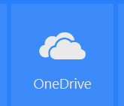

Click on Upload at top
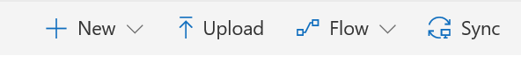

Click Files

Browse for you file in the downloads file.
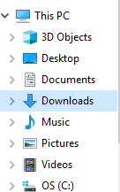

Click on Open

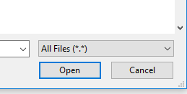
Share the new file by Clicking in the light colored circle by the file name
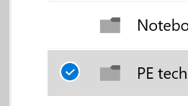

Click on the Share button at the top
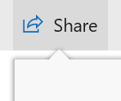

Type diana.repp@dmschools.org in the proper space.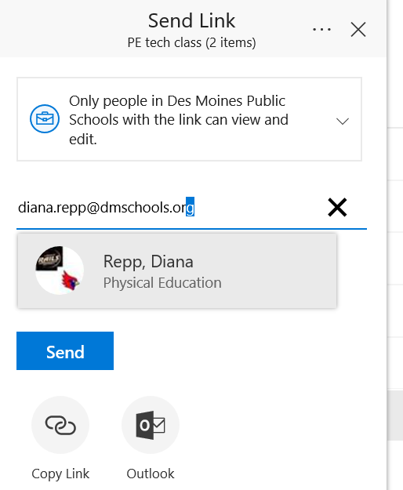

Type everyone’s name in the message area.

Click on Send.

